

Art and Technology

Aboriginal Art

Delightful Decorations

History

* Guy Fawkes and the Gunpowder Plot

English

Spelling, Punctuation and Grammar

Handwriting

Stories with Familiar settings

Information texts

Letters and

Postcards

Poetry

Science

Materials

Our Changing World



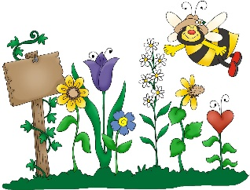

**Cedar Class Curriculum Web**

*What will Cedar Class be learning about in the Autumn Term?*



Geography

Map work

At the Farm



Maths

Number and Place Value

Addition and Subtraction

Multiplication and Division

Money

Measurement

Data Handling

Geometry

PE

Balance and Coordination

Multiskills

Active Maths



Computing

E-Safety

Multimedia

**Reading:**

Your child will receive a new reading book and reading record. Please read with your child at home every evening where possible. This has a massive impact on the children’s writing and builds their bank of vocabulary. Please remember to sign your child’s reading record when they have read.

*The children are expected to bring their reading book to school each day, even if they haven’t read.

**Welcome to Cedar Class!**

We have a very busy term ahead in year 2 as we settle in to a new and more formal way of learning. The children have already begun working super hard and trying their best which is fantastic.

This document highlights our key activities, reminders and important dates for this term.



**Tapestry is back!**

This term, we are hoping to continue to use Tapestry as a way of sharing the children’s learning and achievements with you. I will let you know when we are up and running! If you are having any problems accessing Tapestry when we do get started, please let me know and I can have a look for you.

**Homework:**

Homework this term will usually be given out on a Friday and will be due back in on the Wednesday of the following week please.

*Please encourage your child to practise their times tables as this will really help them in school. We are going to be focussing on learning our 2, 5 and 10 times tables this year.

Thank you. ☺

**Key weekly activities:**

PE

PE this half term will be on Wednesday mornings. The children must have their PE kit (indoor and outdoor) in school until half term.

After October half term, it is likely that PE will change to an alternative day during the week as we move on to multiskills.

Forest School

Forest school will be on Wednesday afternoons. The children’s outdoor kit can stay in school. Please make sure your child has additional layers for the cold weather and waterproofs!

Swimming

Swimming will be on a Friday afternoon each week.