Where our food comes from - farming in Spring
We have all recently realized how important our food supply is and so it is a good opportunity to think about where it comes from and who is working to produce it.
Much of our food is produced by farmers around the world. We can be very proud of the great food produced in this country, and support our farmers, so that it is always there when we need it.

‘Field to Fork’ is based at the Hirsel, near Coldstream and is in an area where most farms are arable (crop growing). Here are some activities about how our crops are grown.
- I Spy Farming – printable tick sheet included
- A video about arable farming to watch:
https://www.youtube.com/watch?v=9hAS6RpTgQ8
- Foods made from wheat, barley or oats
- Design your own tractor
https://youtu.be/GRpqf3VkVJc
- Bake Cheddar scones

I Spy Farming
If you can see some farmland when you are out for your daily exercise, or if you are lucky from your window, can you spy what is happening?
Spring is a busy time for farmers, there is a lot to do whether they are livestock or arable farming. What you will see will depend on what type of farms are where you live – so you will not find all of these!

- Thin green spikes of new cereal plants coming through the ground (looks like grass but is in rows!)

- Taller, thicker spikes of the winter wheat, barley and oats sown last autumn

- Tramlines in the crops – the unsown tracks to allow any work to be done without damaging the crop

- A tractor at work, cultivating the land
- Machines planting a crop into bare soil
- Fertiliser being spread (this machine is usually carried by the tractor)

- A sprayer looking after the health of the crop
- A field of oil seed rape turning yellow as it flowers
- New-born calves now out grazing with their mothers
- A bird scarer
- A muck heap (you’ll smell it too!) – organic manure that has come from the cattle shed and will be spread on the land to fertilise it

- New-born lambs with their mothers, the ewes
- A field planted with potatoes – it will have deep ridges running straight

Foods made from wheat, barley or oats
Have a look at the ingredient list on the foods (and drinks) in your cupboards and find those that contain any of these 3 cereal crops. There may be some surprises – look at vinegar, Mars Bars etc!
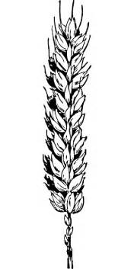  wheat | 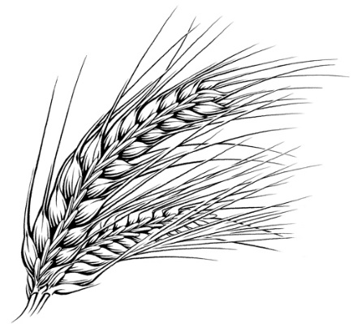  barley | 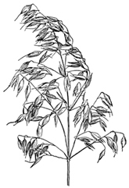  oats

These crops will be stored on the farm once they are harvested in July, August and September before they go to a mill or maltings, and then a manufacturer to become the food we eat.

Design your own tractor
Tractors are amazing machines which provide the power to do all sorts of tasks on the farm.
Check out ‘How tractors work – the magic of Farming’ at https://youtu.be/GRpqf3VkVJc
Tractor drivers on arable farms spend long hours in their tractors in the spring. So as well as being designed for all sorts of tasks, they have features to make them comfortable such as air conditioning, well sprung seats.
Can you design some further comfort and fun features for a tractor – the funkier and wilder your imagination the better!, A tractor outline which can be printed is on the next page or you can draw your own. Add labels to explain what you have added.
Or you can colour it in.

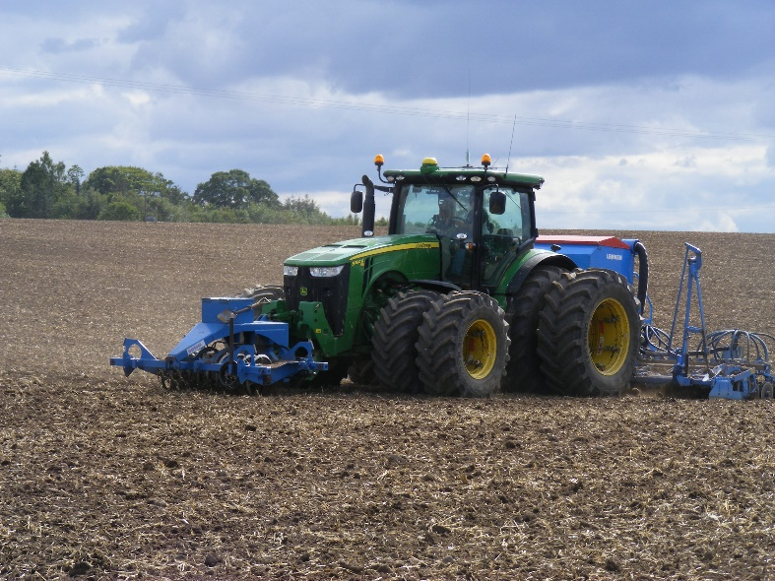

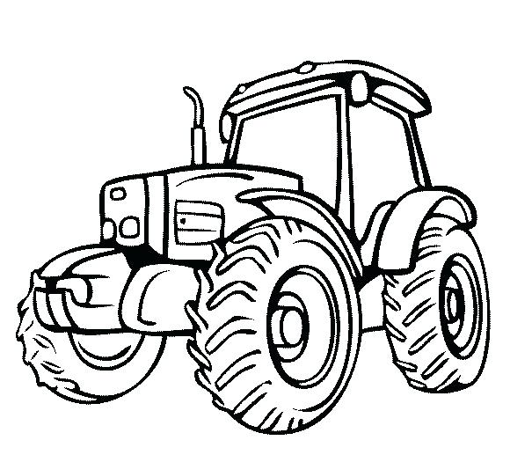

Cheddar Scones

Makes 16

200g (7oz) self-raising flour
1 level tsp baking powder
50g (2oz) butter or margarine
25g (1oz) porridge oats
30g (1 1/2oz) strong grated cheddar
150ml semi skimmed milk

Sift flour and baking powder into a bowl. Cut butter into small pieces and add to flour.

Rub butter into flour until the mixture looks like fine breadcrumbs.

Stir in porridge oats and cheese and then carefully mix in milk.
(You may need to add a little more milk if the mixture looks too dry).

Sprinkle a little flour onto your table and then put the dough on top.

Roll your dough carefully until it is about 1cm thick.

Using your cutter make circles then squeeze scraps of dough together and roll out again to make more circles.

Place your circles on a lightly greased baking tray leaving a little bit of space between each one.

Bake in a hot oven 230 o C 450 o F gas mark 8 for 12-15 mins.
Lift onto a wire rack to cool.

