Cedar Class Curriculum Web
What will Cedar Class be learning about in the Autumn Term?
English
Spelling, Punctuation and Grammar
Handwriting
Stories with Familiar settings
Information texts
Letters and Postcards
Poetry
Art and Technology
Super Sculptures
Perfect Pizzas
Christmas crafts!
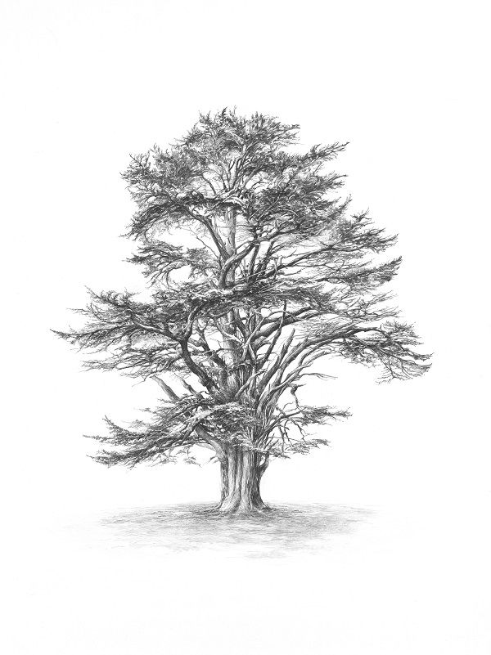
Science
Materials and their properties
Computing
E-Safety
Technology in our lives

Maths
Number and Place Value
Addition and Subtraction
Multiplication and Division
Money
Measurement
Data Handling
Topic
Explorers – Neil Armstrong and Christopher Columbus
Continents and Oceans

PE
Gymnastics
Balance and Coordination
Team games

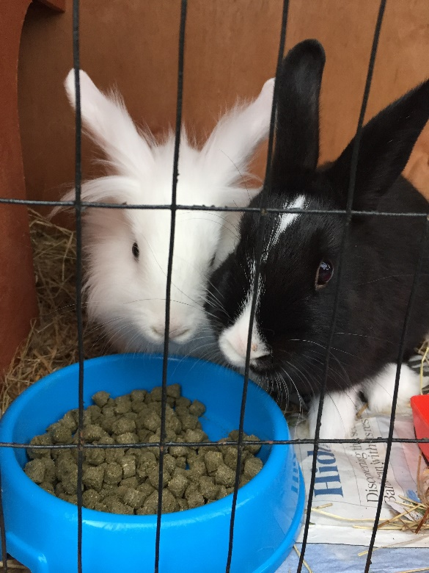
Reading:
Please read with your child at home every evening. This has a massive impact on the children’s writing and builds their bank of vocabulary. Please remember to sign your child’s reading record when they have read.

Tapestry is back!
In year 2, we are going to be using tapestry as a way of sharing the children’s learning and achievements with you. We will be setting up your accounts once we have received confirmation of your email address details on the data collection sheet.
Welcome back and welcome to Cedar Class!
We have a very exciting year planned. This document highlights our key activities and important dates for this term.
We are all very excited about our two new additions – the children in Cherry and Cedar class loved naming them. We had to have 2 votes in Cedar class! We have named them Ralphie and Hutch!
*Just a reminder that if you do have concerns about your child touching the rabbits at all then please return the reply slip by the end of this week. Thank you!

Some important dates:
Thursday 20th September – School photos
Wednesday 26th September – Woodhorn Trip (more information to follow)
Wednesday 3rd October – Phonics and Maths information open morning
Tuesday 9th October – Harvest Festival at 2pm
Friday 19th October – Key Stage 1 Assembly at 3pm
Key weekly activities:
PE
We will have gymnastics this half term every Monday afternoon. The children should have all of their PE kit in school and this can be left in school for the half term.
Forest School
Forest school will be on Thursday afternoons. The children’s outdoor kit can stay in school.
Swimming
Swimming will be on a Friday afternoon.

