Music
More complex nursery rhymes
Steady beat
Harvest/Christmas
Autumn
Term

Geography
Where do I live?

Literacy

- Beegu
- The Night Box
- Pumpkin Soup
- Humorous poems

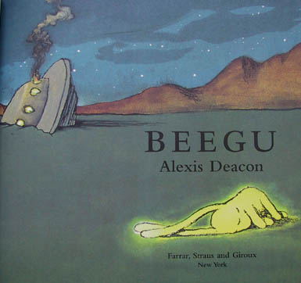
R.E. / P.S.H.E
- Christianity
- Judaism

- Being me in my world
- Celebrating difference

PE

- Cricket
- Swimming

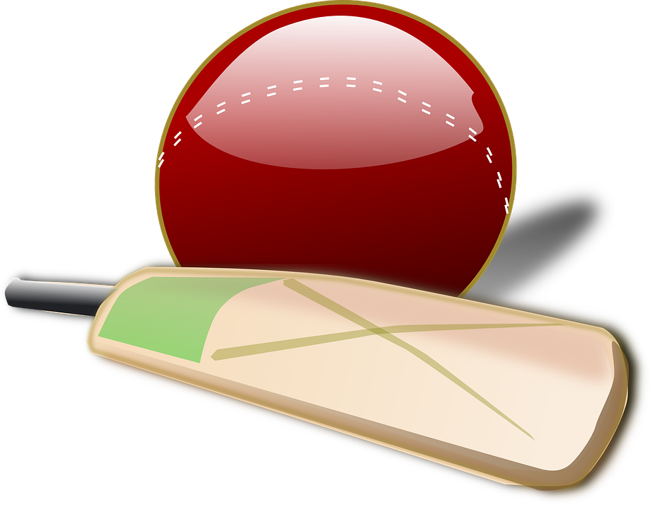

Numeracy

- Counting
- Writing numbers
- Addition
- Subtraction
- Shapes and patterns
Science
- Our senses
- Materials

Art/ DT
- Earth art
- Eat more fruit and vegetables
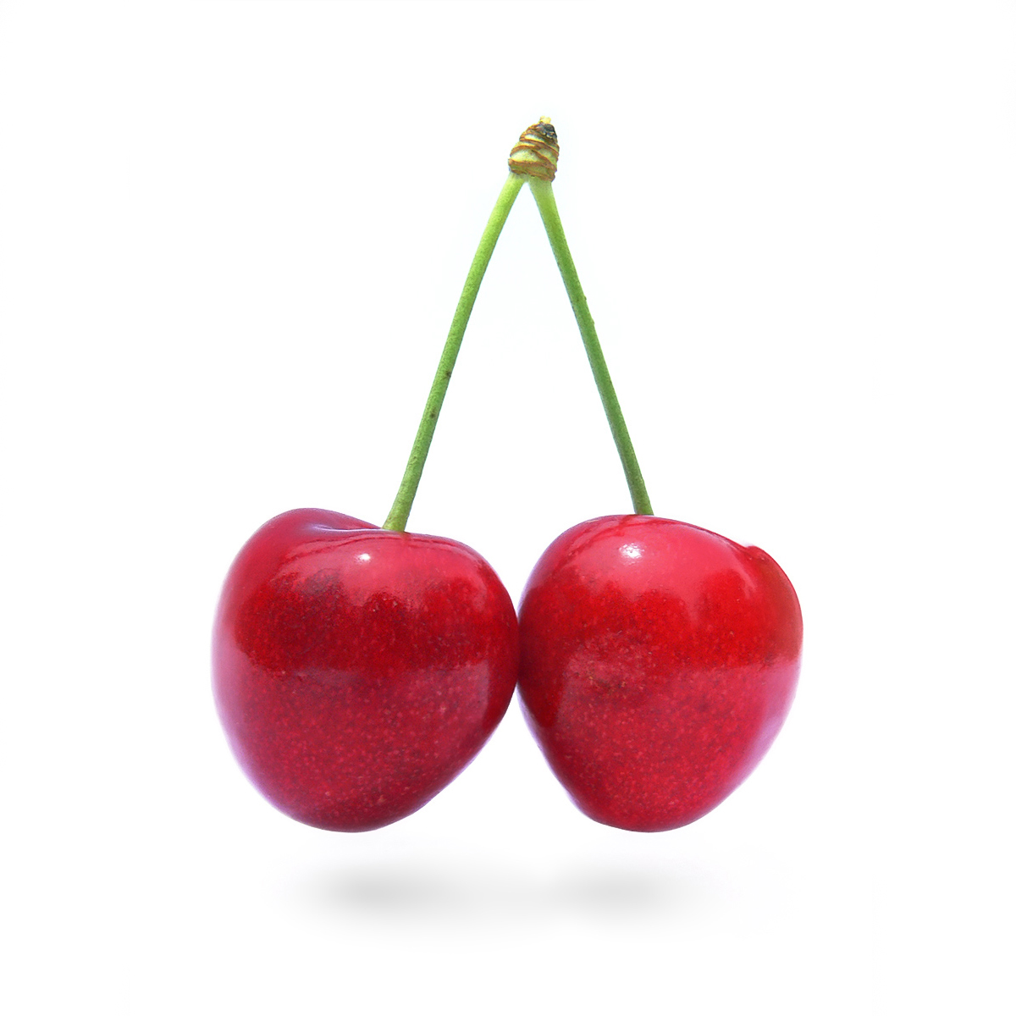

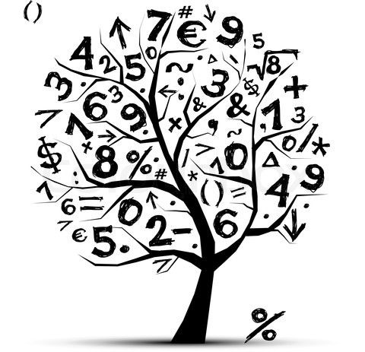
ICT
E safety
Technology in our lives
History

Intrepid Explorers

