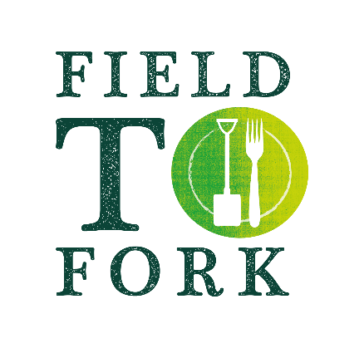
Things to do with sticks!
When out for a walk or in your garden
collect some sticks together and have
some fun with these ‘sticky’ activities!

Remember only to pick up sticks from the ground, never break them off a tree
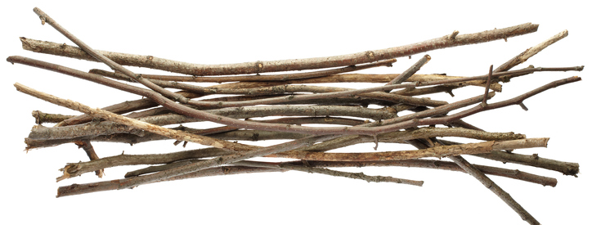
- Something to try:
- Lay them in order, shortest to tallest or thinnest to fattest
  - Lay them out to spell your name
  - Make a number line (1 stick, 2 sticks, 3 sticks etc),
above 10 add a stone/thick stick to represent 10.
  - Lay out a times table (that could need a lot of sticks!)
  - Use the sticks to make roman numerals
…….. and on the following pages
- Something to discover - Identify your Twigs
- Something to build - Stick Tower Challenge
- Something to create - A picture frame
- Something to eat - Yummy Cheesy Sticks

Identify your Twigs
Are your twigs rough or smooth, knobbly or shiny, do they have buds?
Use the Twig ID sheet to try and work out what tree they belong. If they come from your garden they may not be included here, so take the ID sheet with you on a walk and see how many you can find. Many of them are budding now with their new leaves or blossom.
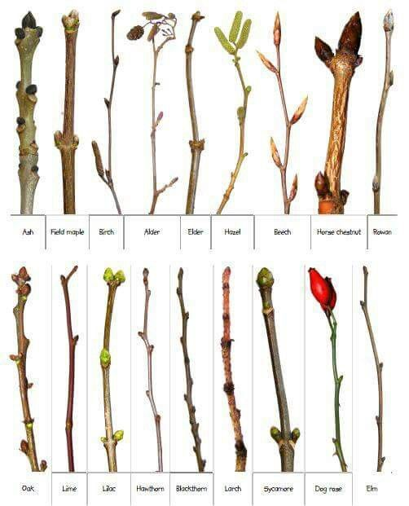
Stick Tower Challenge
How tall a tower can you build with the sticks you have found?
Decide whether you want to use string/wool or playdough to help hold the twigs together or you can decide to do it naturally.
Work together or have a competition with someone else!
Here are some ideas:

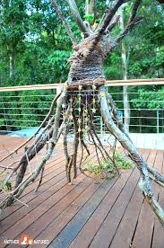
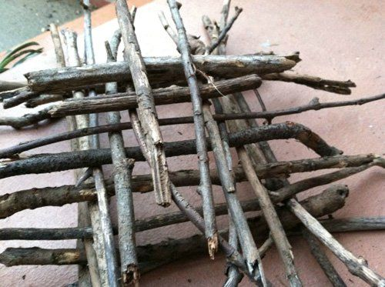

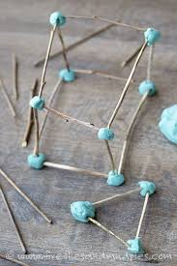

Make a picture frame
Picture frames help us focus on a distant view, on something nearby or something special.
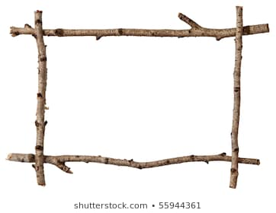
Make a decorated picture frame and then decide what to put in it!
- Collect either 4 sticks all the same length to make a square frame, or 2 long sticks of the same length and 2 shorter ones. You can choose different interesting sticks or smooth straight ones.

- Overlap the ends of the sticks and lash together with wool or string to make a square or a rectangle. Great practice for tying knots as they will need to be firm. Here is how to square lash:
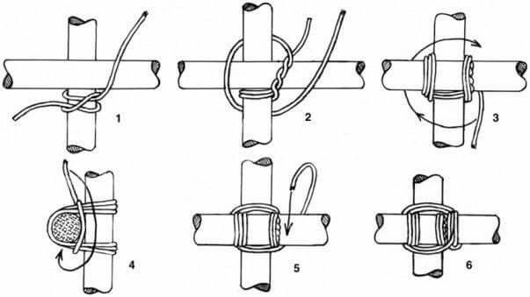

- Now either twist creeper stems or more wool/string around your frame and then decorate it with natural materials you find, poking them between the creeper/string. Remember only to use what is not still living.

- Attach another piece of string as a hanger if you wish.

- Find what you would like to frame!
Yummy Cheesy Sticks
Makes about 24
175g plain flour
Pinch salt
100g butter
75g mature cheddar cheese, grated
25g parmesan, grated (optional)
Pinch English mustard
Pinch cayenne pepper
1 egg yolk

- Sift the flour and a pinch of salt into a bowl.
- Using your fingertips, rub in the butter until all the lumps are gone and the texture is like fine breadcrumbs.
- Stir in the cheese, mustard powder, cayenne, and egg yolk.
- Add 1-2 tablespoons of cold water and mix to a firm dough.
- Wrap in cling film and chill in the fridge for 30 minutes.
- Preheat the oven to 190C/375F/Gas 5. Line a baking sheet with baking parchment.
- Roll out the dough on a floured surface to a rectangle, roughly the thickness of a £2 coin. Cut into 1cm strips.
- Transfer carefully onto the lined baking sheet and bake for 10-15 minutes, until crisp, then leave to cool on the tray.

