

English

Spelling, Punctuation and Grammar

Handwriting

Stories with Familiar settings

Information texts

Letters and

Postcards

Poetry

History

Significant Individuals

* Florence Nightingale
* Super Scientists

Art and Technology

Giuseppe Arcimboldo

Super Sculptures

Science

What is in your habitat?

The Apprentice Gardener

Our Changing World



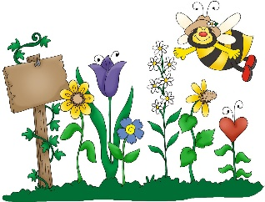

**Cedar Class Curriculum Web**

*What will Cedar Class be learning about in the Spring Term?*



Geography

Map work

Comparing Africa with the UK.



Maths

Number and Place Value

Addition and Subtraction

Multiplication and Division

Money

Measurement

Data Handling

Geometry

PE

Dance

Balance and Coordination

Team games

Computing

E-Safety

Multimedia

**Reading:**

Please read with your child at home every evening. This has a massive impact on the children’s writing and builds their bank of vocabulary. Please remember to sign your child’s reading record when they have read.

*The children are expected to bring their reading book to school each day, even if they haven’t read. Please try to help your child to remember this!

**Welcome back and Happy New Year!**

We have a very busy term ahead in year 2.

This document highlights our key activities, reminders and important dates for this term.



**Tapestry is back!**

This term, we are hoping to use Tapestry more as a way of sharing the children’s learning and achievements with you. If you are having any problems accessing Tapestry, please let me know and I can have a look for you.

**Homework:**

Homework this term will usually be given out on a Thursday and will be due back in on the Tuesday of the following week please.

*Please encourage your child to practise their times tables as this will really help them in school. We are learning our 2, 5 and 10 times tables at the moment.

Thank you. ☺

**Key weekly activities:**

PE

We will have dance this half term every Monday afternoon. The children should have their PE kit in school and this can be left in school for the half term.

Forest School

Forest school will be on Thursday afternoons. The children’s outdoor kit can stay in school. Please make sure your child has additional layers for the cold weather!

Swimming

Swimming will be on a Friday afternoon each week.